Assignment Tasks
Task 1: Prompt Categorization
Categorize the following prompts into types (Instructional, Conversational, Visual, etc.) and explain your reasoning:
No. | Prompt | Type | Reasoning
1 | 'Generate a logo for a tech startup using neon colors.' | Visual Prompt | It asks an image-generation tool (DALL·E, Midjourney, Canva AI) to produce a graphic. The output is an image, and the prompt describes visual attributes (logo, neon colors, tech style). It also contains an instruction verb, "Generate".
2 | 'Explain blockchain to a 5-year-old.' | Instructional Prompt (with audience framing) | It gives a direct command ("Explain") for a specific task, and defines the audience (a 5-year-old) to control the tone and complexity. It can also be used as a conversational question.
3 | 'You are a UX designer. Suggest improvements to this app layout.' | Role-based Prompt | It first assigns a persona ("You are a UX designer") so the model answers from that expert point of view, and then gives an instruction ("Suggest improvements"). Role-based framing is a technique listed in 1.4.
Task 2: Refinement Practice
Vague prompts were refined by adding the purpose, audience, details, style, format and constraints.
No. | Original (vague) prompt | Refined prompt | What was added
1 | Make a poster. | Create a poster for a school science fair with a blue background, cartoon robots, and bold text saying SCIENCE EXPO 2025. | Purpose, colors, theme, exact text (given example)
2 | Write about AI. | Write a 200-word article on how Artificial Intelligence is used in healthcare, for college students, in simple English, with 3 real examples and a one-line conclusion. | Topic focus, length, audience, tone, structure
3 | Draw a city. | Generate a futuristic Indian city at night with neon signboards, flying cars and rain-soaked streets, cinematic wide-angle view, 16:9 aspect ratio, highly detailed. | Setting, objects, mood, camera view, ratio
4 | Write a program. | Write a Python program that accepts a list of numbers from the user and prints the largest number without using the max() function. Add comments and show one sample input and output. | Language, task, constraint, output format
5 | Help me study. | Create a 7-day study timetable for a second-year engineering student preparing for a Data Structures exam, with 3 hours of study per day, in a table with day, topic and revision slot. | Subject, duration, level, output format
6 | Make a video. | Create a 10-second cinematic video of a robot painting a canvas in a bright art studio, soft morning light, slow camera pan, realistic style, 16:9. | Subject, action, duration, lighting, camera, style
Task 3: Prompt Design Exercise
Five original prompts were designed for different domains.
No. | Domain | Tool | Prompt
1 | Text-based | ChatGPT / Claude | Act as a career counsellor. I am a second-year AI & Data Science student in Pune. Suggest 5 internship paths for the summer, and for each give the skills needed, a free learning resource and one beginner project. Present the answer in a table.
2 | Image-based | DALL·E | A futuristic smart college campus in Pune at golden hour, students using holographic displays, glass buildings with green terraces, warm cinematic lighting, ultra-detailed digital art, 16:9.
3 | Video-based | SORA | A 10-second cinematic shot of a small robot walking through a rainy neon-lit Indian street market at night, reflections on wet ground, slow tracking camera movement, shallow depth of field, realistic style, 16:9.
4 | Coding / Logic | ChatGPT / Claude | You are a Python mentor. Write a function is_palindrome(s) that ignores spaces, punctuation and letter case. Explain the logic in 3 steps, add comments, and include 4 test cases with expected output.
5 | Education / Training | ChatGPT / Claude | Act as a teacher. Explain how a neural network learns to a first-year student using a cricket coaching analogy. Use simple language, keep it under 200 words, and end with 3 multiple-choice questions with answers.
Practice Activity (Live Testing)
The prompts designed in Task 3 were tested using ChatGPT (text / logic), DALL·E (image generation) and other visual tools (Canva AI / SORA). The results were analysed and the prompts refined where necessary.

Prompt 1: Text-based (Claude)
Prompt:
Act as a career counsellor. I am a second-year AI & Data Science student in Pune. Suggest 5 internship paths for the summer, and for each give the skills needed, a free learning resource and one beginner project. Present the answer in a table.
Output (screenshot from Claude):
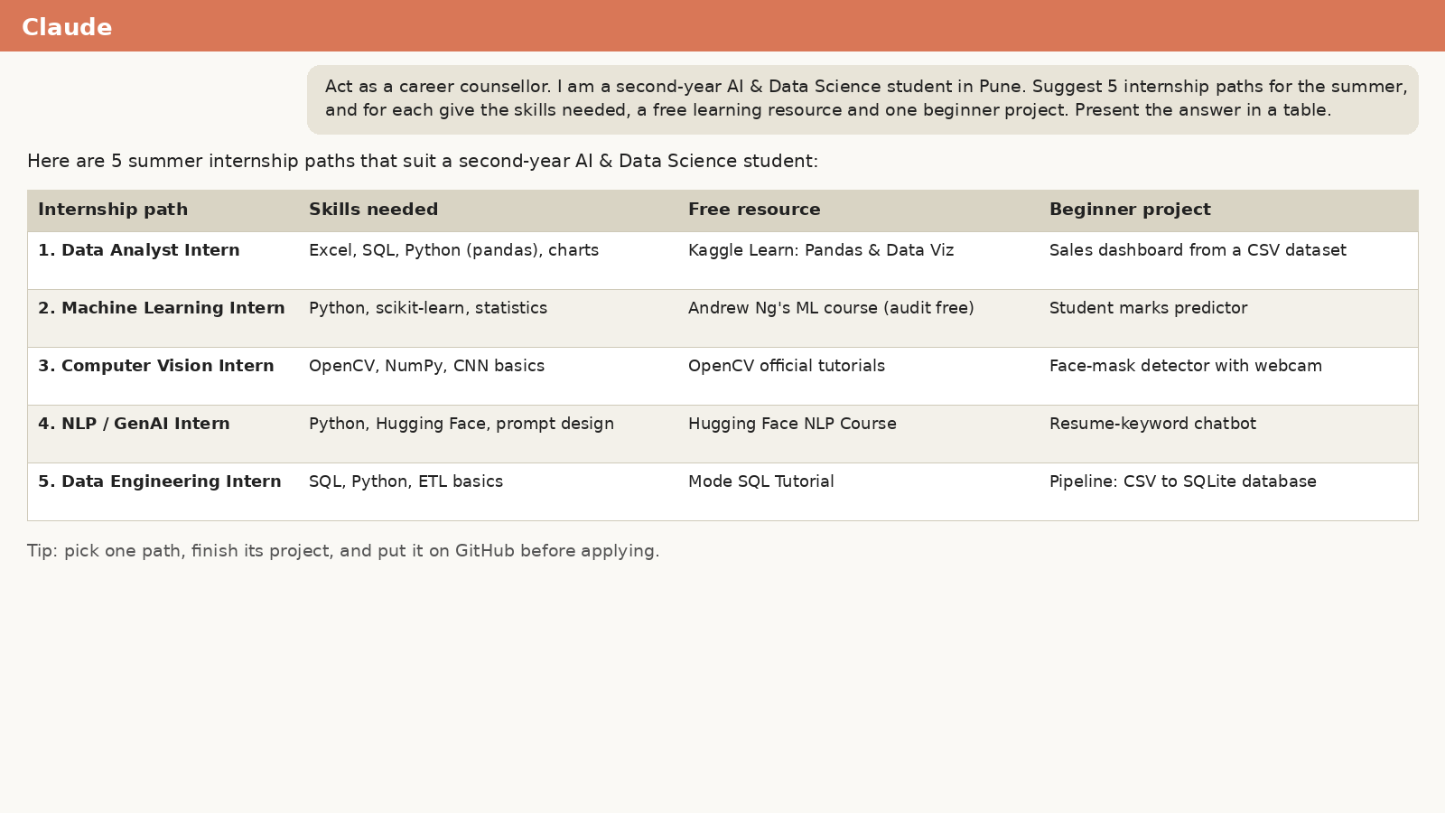
Figure 1: Claude output for Prompt 1
Analysis: The response followed the role, gave exactly 5 paths in table format with skills, resource and project. Because the prompt stated the role, student level and output format, the answer was relevant and well structured.
Refined prompt: Add "Keep each cell under 15 words and mention approximate stipend range in India" to make the table more concise and useful.

Prompt 2: Image-based (DALL·E)
Prompt:
A futuristic smart college campus in Pune at golden hour, students using holographic displays, glass buildings with green terraces, warm cinematic lighting, ultra-detailed digital art, 16:9.
Output (screenshot from DALL·E):

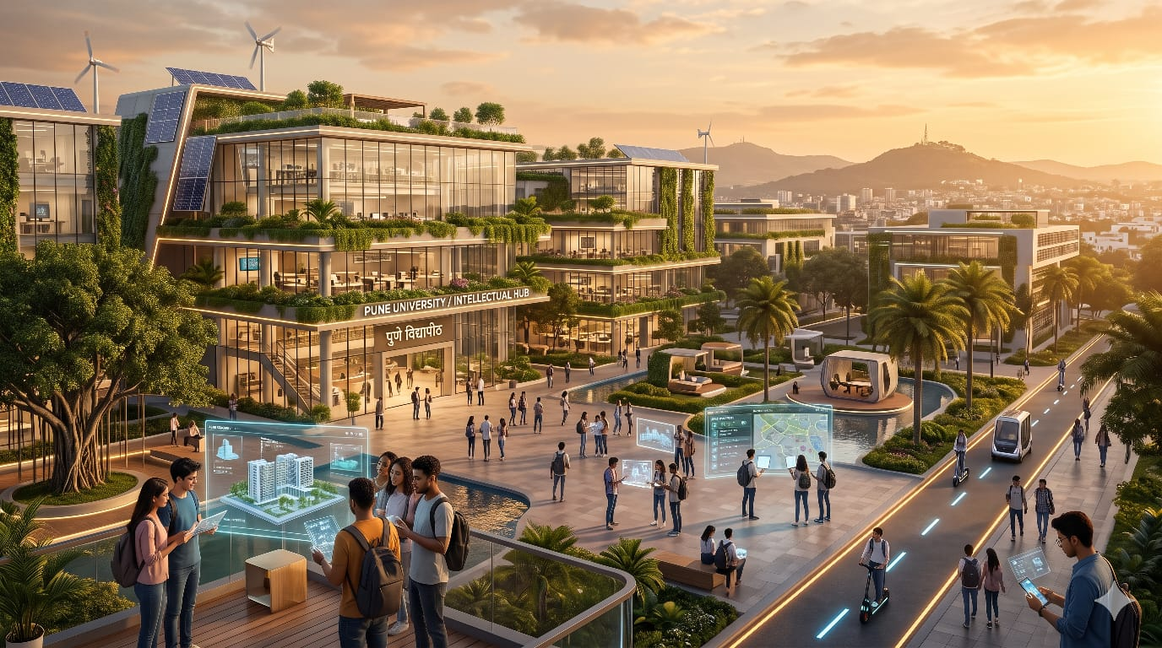Paste screenshot here
(16:9 ratio)
Figure 2: DALL·E output for Prompt 2

Analysis: The image matched the setting, lighting and style because each visual element (place, time, objects, mood, style, ratio) was described. Small details such as the exact number of students or text on boards may vary between generations.
Refined prompt: Add "no text or watermark, students in casual Indian college wear, clear sky with a few clouds" to control unwanted elements.

Prompt 3: Video-based (SORA)
Prompt:
A 10-second cinematic shot of a small robot walking through a rainy neon-lit Indian street market at night, reflections on wet ground, slow tracking camera movement, shallow depth of field, realistic style, 16:9.
Output (screenshot from SORA):

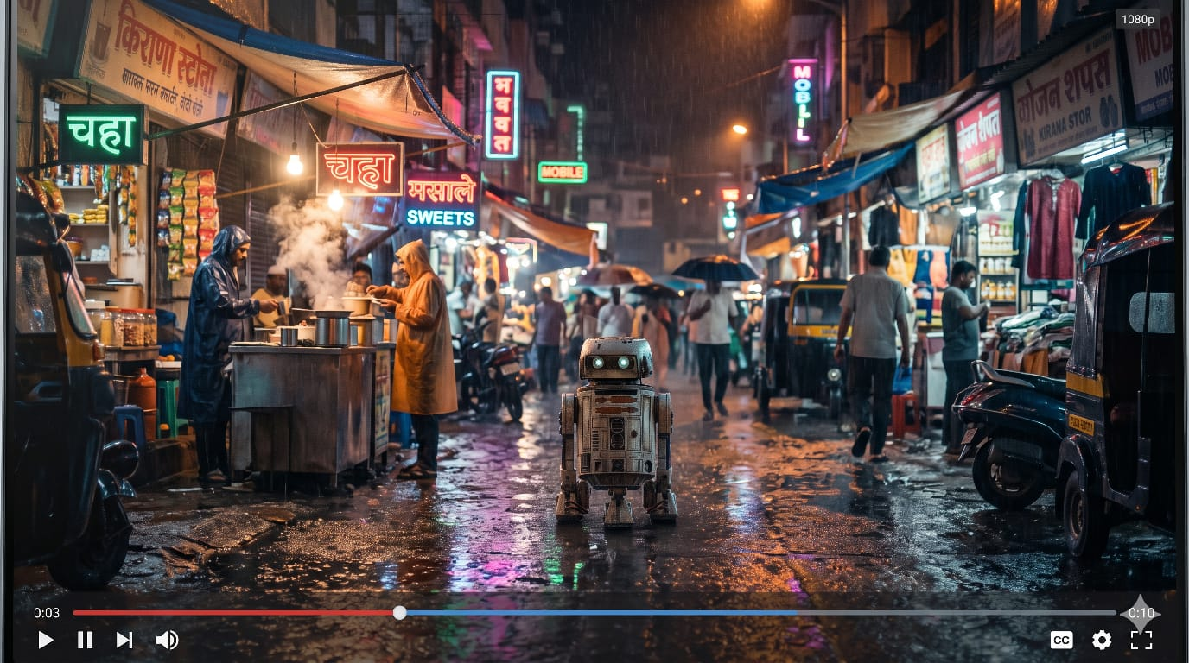
Figure 3: SORA output for Prompt 3

Analysis: Specifying subject, action, environment, camera movement and duration gave a coherent short clip. Video models may struggle with fine details like hands or small text, so keeping a single clear subject and action works best. (If SORA is not accessible, a similar tool such as Canva AI / Google Veo can be used.)
Refined prompt: Add "robot has a rounded white body with blue glowing eyes; keep one continuous shot with no cuts" for consistency of the character.

Prompt 4: Coding / Logic (Claude)
Prompt:
You are a Python mentor. Write a function is_palindrome(s) that ignores spaces, punctuation and letter case. Explain the logic in 3 steps, add comments, and include 4 test cases with expected output.
Output (screenshot from Claude):

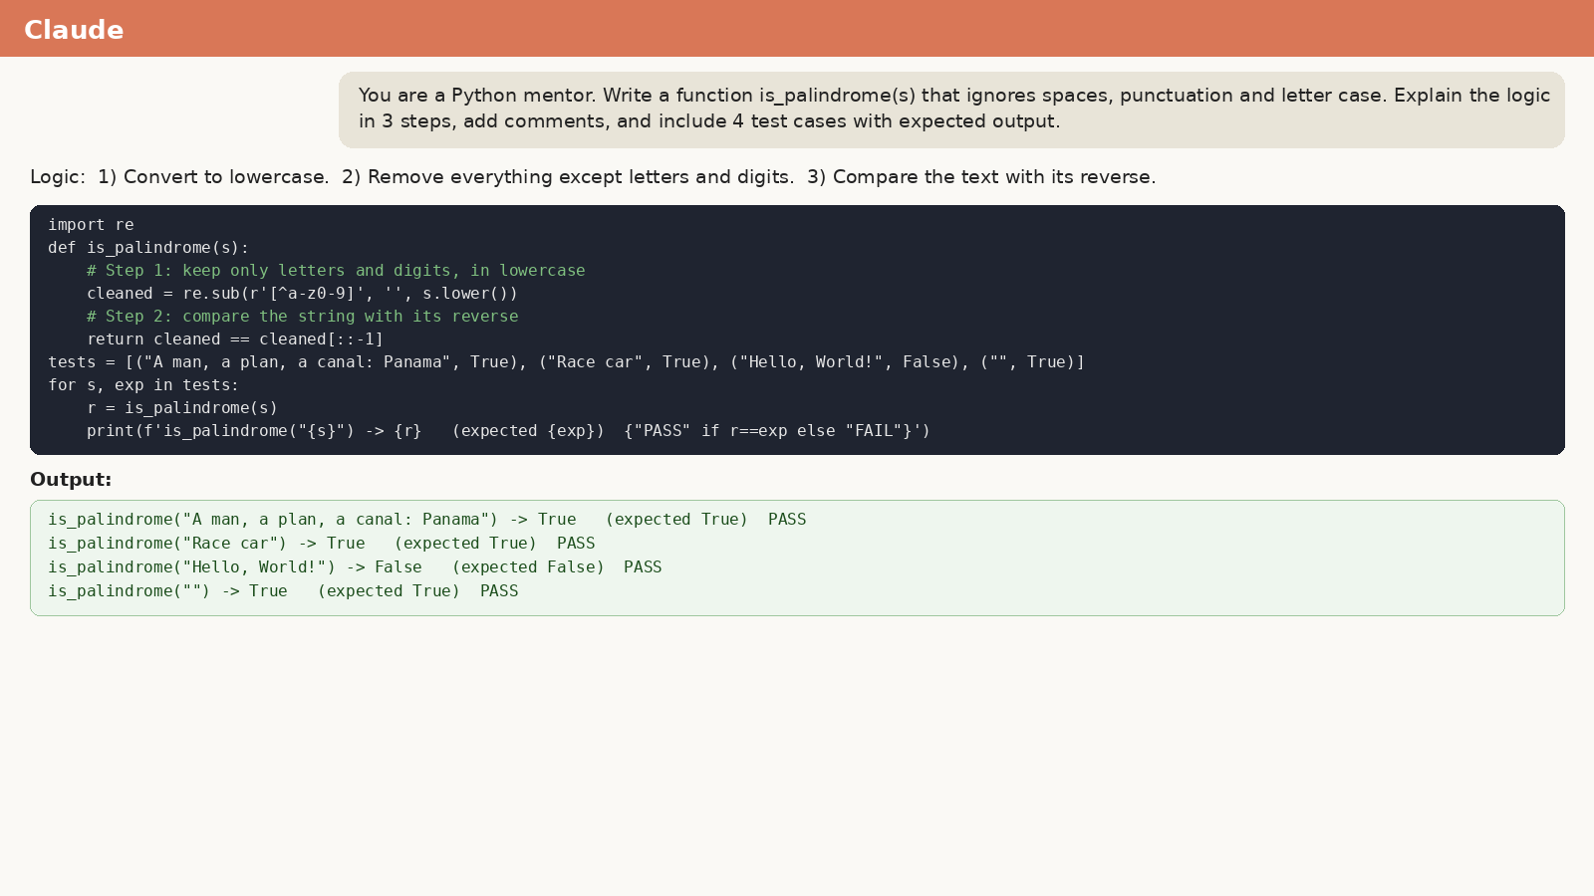
Figure 4: Claude output for Prompt 4

Analysis: The model produced a working function (clean the string, compare with its reverse), a 3-step explanation and test cases such as "A man, a plan, a canal: Panama" -> True. Naming the function, constraints and number of tests removed ambiguity.
Refined prompt: Add "also give the time complexity and an alternative two-pointer solution" for a deeper answer.

Prompt 5: Education / Training (Claude)
Prompt:
Act as a teacher. Explain how a neural network learns to a first-year student using a cricket coaching analogy. Use simple language, keep it under 200 words, and end with 3 multiple-choice questions with answers.
Output (screenshot from Claude):

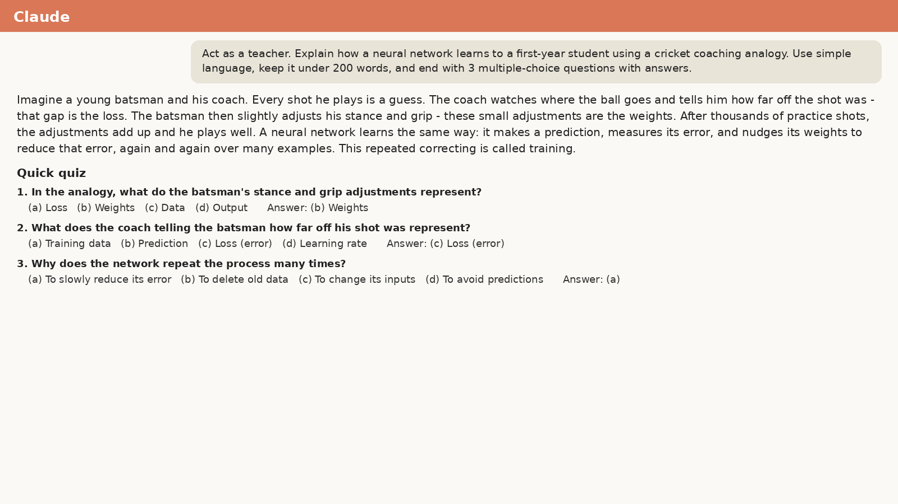
Figure 5: Claude output for Prompt 5

Analysis: The analogy (coach correcting a batsman after every shot = weight updates by backpropagation) made the concept easy to follow. The word limit and the quiz were respected because they were stated explicitly.
Refined prompt: Add "avoid technical jargon; define the terms weights and loss in one line each" if the first answer feels too technical.
Conclusion
Through this assignment we categorized prompts, refined vague prompts into effective ones, and designed and tested original prompts across text, image, video, coding and education domains. Clear instructions, defined role, audience, format and constraints, together with iterative refinement, give more accurate and useful AI output.

